EMU-2 Meter Monitor getting connected with Smart Meter

**Smart Meter Configuration**

1.Follow the steps below to configure the Smart Meter via optical cable.

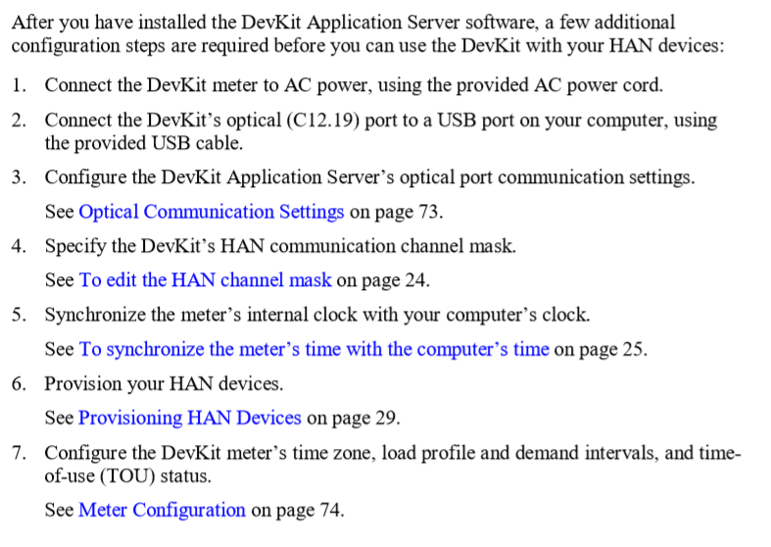

2. In step 6, the MAC ID and Install code should be registered.

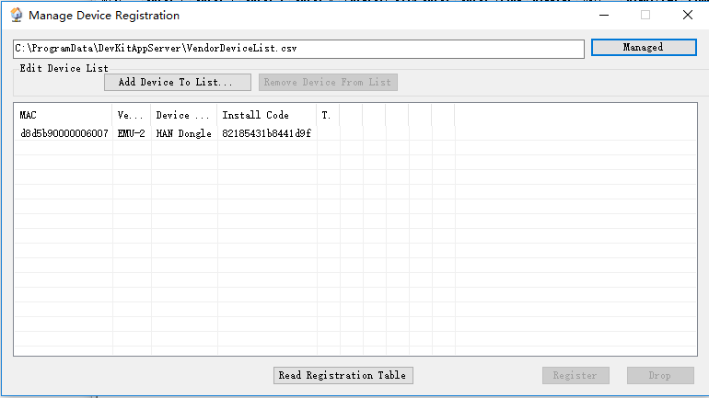

Once registration finished, then click HAN registration, the device info should be like this picture. The HAN key is generated from Install code.

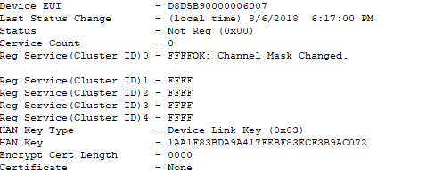

3. Then Turn HAN join on.

**On EMU monitor side**

Basically, you do not need to do anything, just start the power and it will search for the meter automatically and then join. If the screen shows **connection lost, rejoining meter,** then you need to Hard Reset the device.

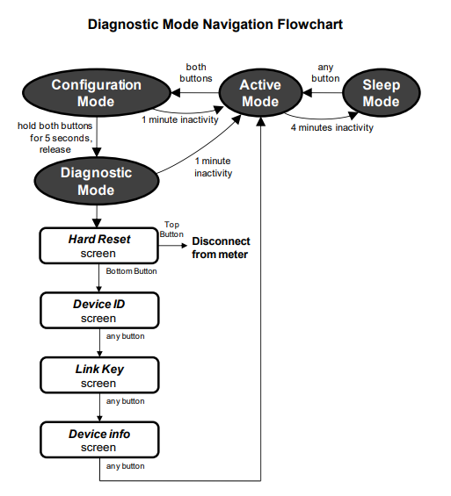Hard Reset Steps:

Once it is connected, the monitor should show the synchronous time.

